**IFB299 Personal Portfolio 1**

**Name: Virginia IP n8810532**

**Due Date 17/9/2015**

This document states five significant and distinctly different artefacts from the current release that I have contributed to the group. It includes a brief description of each artefact describing its contribution in the context of the project.

As an Information System and business student, we focused more on non-technical tasks in the group. Here are the five artefacts:

**Artefact 1 – BPMN describing the proposed Mr. David’s new property management system** 2

**Artefact 2 – Team Blog** 3

**Artefact 3 – Building Property UI using FileMaker** 4

**Artefact 4 – Business Letter to Client (peer review1)** 6

**Artefact 5 – Test Cases** 7

# **Artefact 1 – BPMN describing the proposed Mr. David’s new property management system**

I found BPMN is a helpful tool in describing business processes and mapping tasks to execution logic. Client like Mr. David and his staff are more comfortable with visualising business processes in a flow-chart format. As a result, it can greatly bridge the gap between technical developers and intended user. The BPMN graph I created does not includes all function in the product backlog, but instead I would like to focus on the main processes of renting a properties. Functions for example editing properties details are not included in the diagram. It is reasonable to expect the graph might be look different in the later stage of development because functions are keep changing in an agile development environment. Please read **PropertyManagementDiagram.pdf** for the details.

In the diagram, it gives an idea how the does the whole system works. The boss, staff (agent), and owner are using the standalone system developed on visual studio, while tenant or prospected tenant would use online webpage to browse for properties.

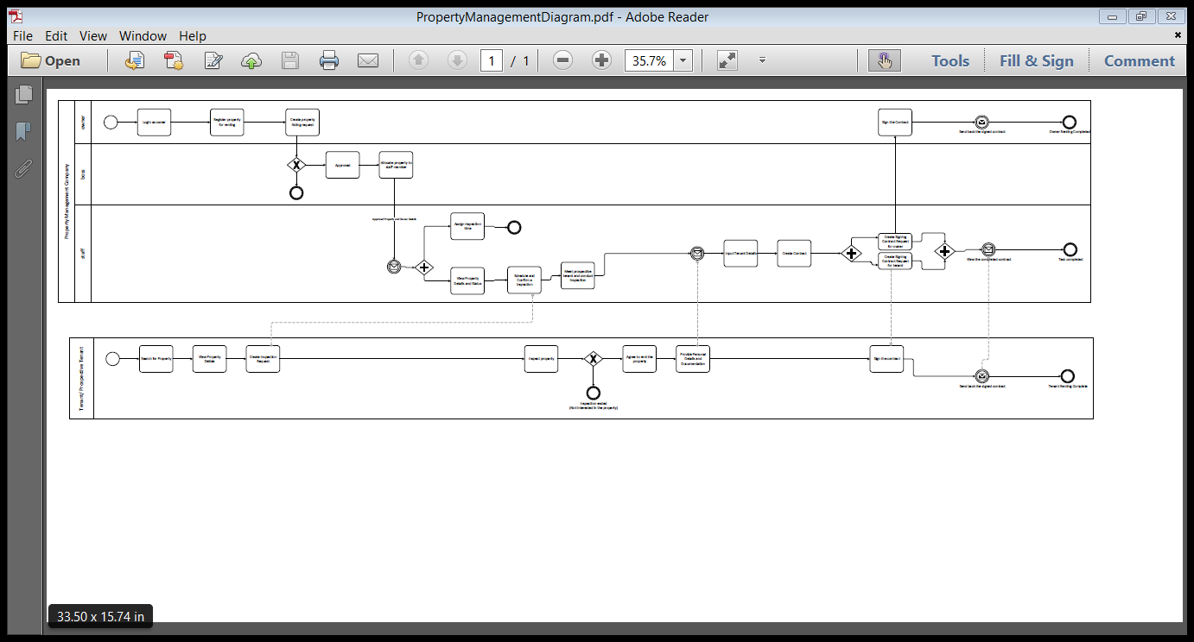

I used visio to draw this BPMN, and I have verify the by its build-in diagram validation function. It does not find any issue or error in the diagram.

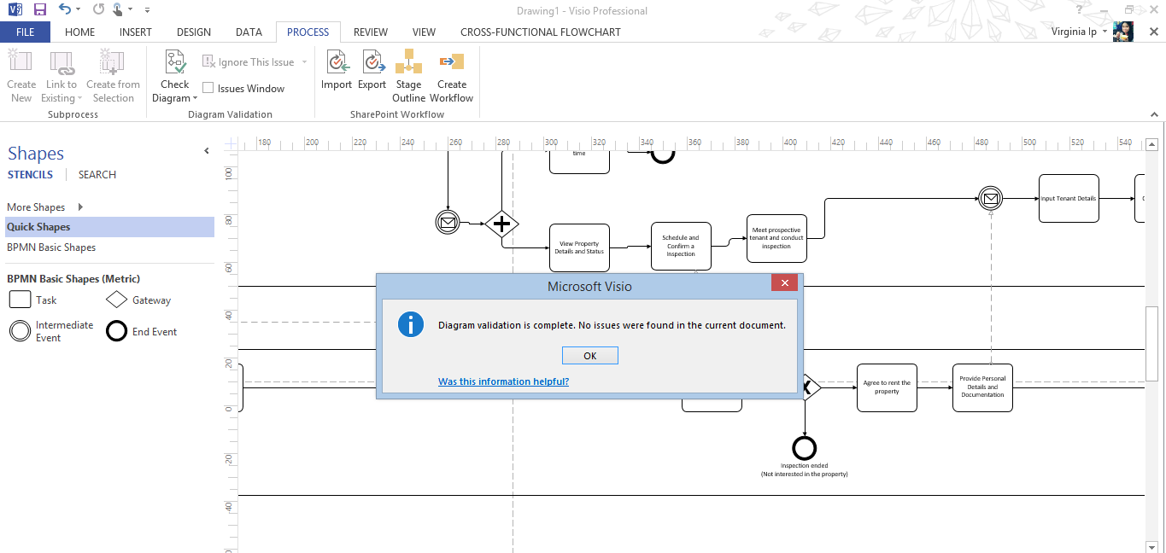

# **Artefact 2 – Team Blog**

Our group blog was not very well maintained. I took the initiative to add four different entries in September. Writing a blog for the team provides basic summary of what decisions have been made at the workshops, issues discussed, and questions raised. These valuable information provides team members and client team a reminder of what had happened and thus helps tracking progress and aiding our planning.

More importantly, it is a good time for us as a student to reflect on our performance in the unit. Do we understand the concepts introduced in the lectures? Can we put theories into actions and apply effectively in the group project? As an IS student, it is important to liaise with different stakeholders in the team. These skills would be also very useful in workplace for building a prosperous team.

Please read **Team Blog post.docx** for details.

# **Artefact 3 – Building Property UI using FileMaker**

Prior to this unit, I have no experience in using the software FileMaker. One of the team members Cameron is an experienced user on FileMaker, he taught me some basics of the software. Then I went on explore the functions for a week. I am capable to produce a decent user interface for property details. I have used wide range of fields include textboxes, radio buttons, drop-down boxes and checkboxes. I was able to create containers for holding the properties photo (Later modified by Cameron).

During the designing process, I gathered all required information about a property from task sheet and client’s recommendations. I tried to include all relevant information about a property to give a comprehensive view for the prospected tenant.

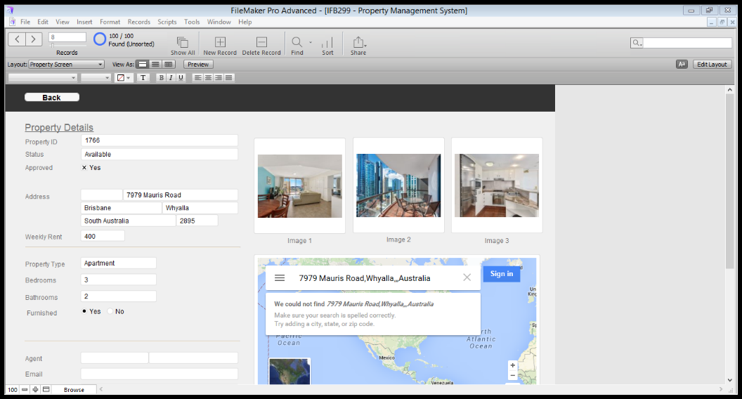

I also tried to learn from similar website like realestate.com to see how they layout the information about a property. The research on different sites gave me a better idea how to group information into categories.

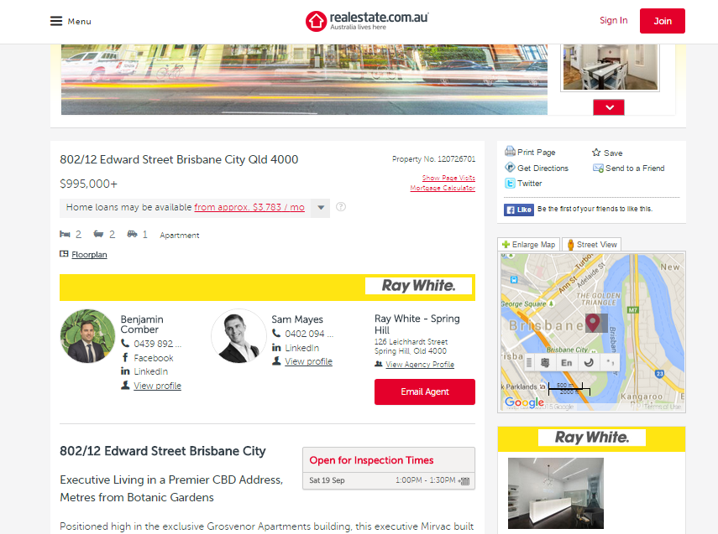

I also draw different types of layout and interviewed a couples of my friends, see which design is most user-friendly. 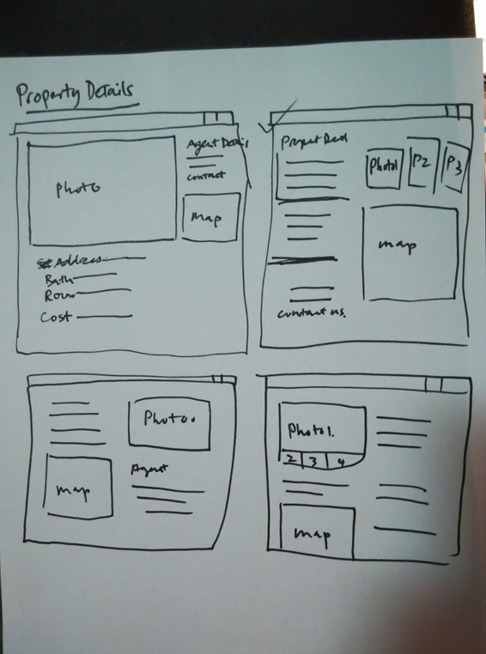

# **Artefact 4 – Business Letter to Client (peer review1)**

The peer review is an opportunity for the client team to provide constructive feedback to their developer team. In week 7 we listened to a presentation by the development team, I was responsible to collect my members’ opinion and write the part relating to “Professionalism of the Presentation”. The letter is formal document to the development team. As a result, I avoided using informal language like contractions and slangs.

Please read **Peer Review 1.docx** for details.

# **Artefact 5 – Test Cases**

I wrote test case for functional testing in order to verify whether we have built a correctly working product. This document can help the team to ensure the system meet the business requirements and acceptance criteria. I listed some possible scenarios to ensure the system accept correct data and reject incorrect inputs. Having this document ready I prepare us find the possibility of using advanced tools like automated testing tools for c# - Nunit and Selenium for webpage.

One of the issues I have encountered when doing the testing is the system is incomplete at this stage. Most of the functions are not ready for me to do testing. But I still think that have a test case document will smooth the testing procedure in the future. Please read **Test Case v1.1.docx** for details.

I wrote test data based on the database on the server.

